Advanced Discretization Strategies for High-Fidelity Voxel MPM: Resolving Stacking and Phase Artifacts on the Body-Centered Cubic (BCC) Lattice

1. Introduction
The simulation of granular and fluid materials within discrete voxel environments presents a unique intersection of continuum mechanics and cellular automata. While the Material Point Method (MPM) has established itself as the gold standard for hybrid Lagrangian-Eulerian simulation of elastoplastic materials, its application within the strict constraints of a "single-occupancy" voxel grid—where each cell holds exactly one particle—introduces severe numerical artifacts. The most prominent of these are artificial compressibility, manifesting as "water stacking," and incoherent phase interactions between sand and water. Furthermore, the adoption of a Body-Centered Cubic (BCC) lattice, while geometrically superior for isotropy, necessitates the derivation of specialized discrete operators that differ significantly from standard Cartesian implementations.
This report provides a comprehensive theoretical and practical framework for resolving these artifacts. By abandoning the traditional Weakly Compressible MPM (WCMPM) equation of state in favor of a divergence-free pressure projection adapted for the BCC 14-neighbor stencil, we can enforce incompressibility without sub-step iteration. Additionally, we address the phase interaction problem by integrating continuum mixture theory into the discrete transport logic, allowing for momentum exchange and saturation-dependent liquefaction even within a quantized particle system. The analysis draws upon recent advancements in sparse grid fluid simulation, discrete element methods, and computational geometry to propose a robust solver architecture suitable for high-performance implementation.

2. Computational Geometry of the Body-Centered Cubic (BCC) Lattice
The choice of a BCC lattice (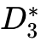) over the standard Cartesian (Simple Cubic, SC) grid is not merely an aesthetic decision but a fundamental geometric optimization for fluid dynamics. Understanding the topology of the BCC lattice is a prerequisite for deriving the correct differential operators required for the pressure solver.

2.1 Lattice Topology and Connectivity
The BCC lattice is defined as a sub-lattice of the integer grid 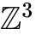 consisting of points 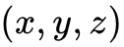 such that 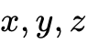 are all congruent modulo 2. Alternatively, it can be visualized as two interleaved Cartesian grids. This structure fundamentally alters the neighborhood connectivity compared to a standard voxel grid. While a Cartesian voxel interacts primarily with its 6 face-neighbors, a node in a BCC lattice possesses a coordination number of 14, interacting with two distinct shells of neighbors.

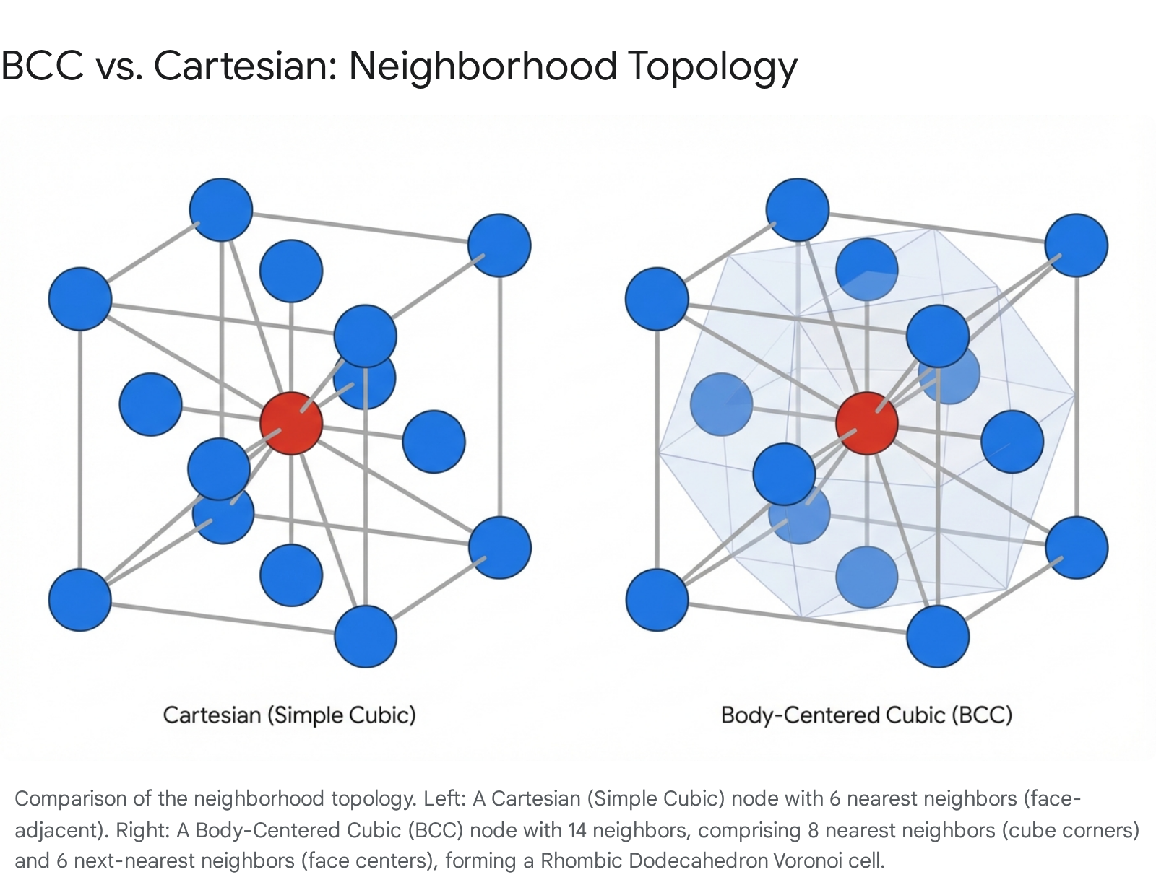

The first shell consists of 8 nearest neighbors located at the vertices of the containing cube, at distance 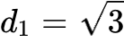 in lattice units. The second shell consists of 6 next-nearest neighbors located at the centers of the adjacent cubic faces, at distance 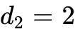. The Voronoi cell of the BCC lattice is the rhombic dodecahedron.¹ This polyhedron approximates a sphere significantly better than the cube of the Cartesian grid, reducing the geometric anisotropy of the grid. In fluid simulations, this isotropy is critical; it prevents the "Manhattan distance" bias where fluids flow preferentially along the cardinal axes. Research indicates that the BCC lattice requires approximately 30% fewer samples to reconstruct a signal with the same fidelity as a Cartesian grid, offering a distinct efficiency advantage for volumetric data.³

2.2 Interpolation Kernels: Box Splines vs. Barycentric Tetrahedra
A critical component of MPM is the transfer of mass and momentum between particles (Lagrangian) and grid nodes (Eulerian). On a BCC lattice, this transfer can be handled via two primary methods: tetrahedral decomposition or box spline interpolation.
The tetrahedral approach involves tessellating the BCC lattice into tetrahedra (typically 24 per unit cell) and using barycentric coordinates for interpolation. While computationally simple, this method introduces 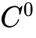 continuity (linear interpolation), which can lead to "grid crossing" artifacts where forces fluctuate discontinuously as a particle crosses element boundaries.² This is particularly detrimental in a single-occupancy simulation, as the lack of neighbor averaging exacerbates the noise.
The superior alternative for high-fidelity fluid simulation is the use of Linear Box Splines. The linear box spline on a BCC lattice is derived from the projection of a 4D hypercube (tesseract) onto 3D space along the antipodal axis.² Unlike the tensor-product B-splines used in Cartesian MPM, the BCC box spline is non-separable but can be evaluated efficiently. It provides a smoother approximation that respects the 14-neighbor symmetry of the lattice. For gradient calculations—essential for the pressure solve—the box spline provides a more consistent stencil than the tetrahedral derivative, which varies depending on the orientation of the tetrahedron containing the particle.¹ By using the box spline basis functions, we ensure that the transfer of velocity from the single particle to the surrounding 14 grid nodes is smooth and isotropic, dampening the "ringing" artifacts often associated with explicit grid transfers.

3. Resolving Water Stacking via Discrete Pressure Projection
The "stacking" artifact described—where fluid voxels pile up vertically under gravity rather than spreading laterally—is a symptom of artificial compressibility exacerbated by the single-occupancy constraint. In standard Weakly Compressible MPM (WCMPM), pressure is computed via an Equation of State (EOS), typically Tait's equation or a stiff ideal gas law: 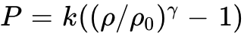. In a single-occupancy grid, the density is effectively clamped (either 0 or 1). There is no intermediate density to drive the pressure gradient until the particles physically overlap, which the single-occupancy rule forbids. Consequently, the pressure term fails to generate the lateral gradient required to push the column of water sideways.
To resolve this, we must replace the EOS-based update with a Projection Method that enforces a divergence-free velocity field (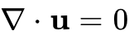). This ensures that even if density is clamped, the velocity field "knows" it cannot converge into a full cell and must divert tangentially.

3.1 The Split-Step Hybrid Scheme
We propose a fractional-step algorithm tailored to the hybrid MPM-CA (Cellular Automata) nature of the simulation. This process integrates the Eulerian pressure solve into the standard MPM cycle to correct the velocity field before the discrete advection step.
The simulation cycle begins with the standard transfer of particle data to the grid. Mass 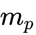 and momentum 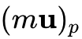 are transferred to the BCC grid nodes using the Linear Box Spline kernel. This establishes an intermediate velocity field 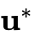 on the grid. Crucially, explicitly incorporating the single-occupancy constraint requires us to interpret this grid velocity not just as a physical flow, but as a transport likelihood map.
Once the intermediate velocity  is established, we proceed to the Pressure Projection. We solve the Poisson equation 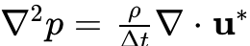 on the BCC grid. The divergence 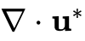 measures how much the fluid is compressing (negative divergence) or expanding. In a "stacked" column of water, the gravity-induced velocity creates strong compression at the bottom. The Poisson solver computes a pressure field that resists this compression. The gradient of this pressure, 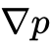, is then subtracted from the intermediate velocity: 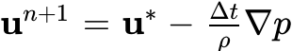. This new velocity 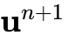 is divergence-free, meaning it has zero net inflow into fully occupied regions. Physically, this manifests as the vertical velocity being converted into horizontal velocity, causing the "stacked" water to slide sideways into empty cells.

3.2 Deriving the 14-Neighbor Discrete Laplacian
Solving the Poisson equation requires a discrete Laplacian operator (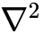) compatible with the BCC lattice. On a Cartesian grid, this is the standard 7-point stencil. On the BCC lattice, we utilize a 15-point stencil involving the center node and its 14 neighbors.⁶
The Laplacian of pressure at node is approximated as:
where 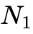 are the 8 nearest neighbors and 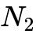 are the 6 next-nearest neighbors. The weights 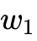 and 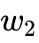 must be carefully calibrated to ensure isotropy and second-order accuracy. Research into optimal sampling lattices suggests weights proportional to the inverse squared distance and the solid angle subtended by the Voronoi face.⁴ Specifically, for a BCC lattice with unit cell size , the weights are typically derived such that the contribution from the diagonal neighbors (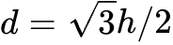) is balanced against the axial neighbors (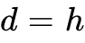).
Implementation of this solver on a GPU (e.g., using Godot's Compute Shaders) requires a matrix-free approach. Instead of building a massive sparse matrix, we iterate over the grid using a Red-Black Gauss-Seidel or Jacobi scheme. For each node, the compute shader fetches the pressure values of the 14 neighbors from the 3D texture (or flattened buffer), computes the Laplacian, and updates the local pressure. Given the constraints of real-time simulation, full convergence is rarely necessary; 4-8 iterations per frame are generally sufficient to generate enough "repulsive" pressure to prevent stacking, even if the field isn't perfectly divergence-free.⁸

3.3 Boundary Conditions and Solid Interactions
The pressure projection must respect solid boundaries (terrain, rigid bodies) to prevent fluid leakage. We apply a free-slip condition at the boundaries. In the divergence calculation step, if a neighbor is a solid voxel, we replace its velocity with the solid's velocity (typically zero for static terrain) projected onto the face normal. In the pressure update step, we enforce a Neumann boundary condition (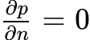) by setting the pressure of solid neighbors equal to the pressure of the fluid cell itself, effectively nullifying the flux across that boundary.⁸ This ensures that pressure builds up against walls, allowing water to pool and stack against obstacles, but not against itself in open space.

4. Single-Occupancy Advection: The Hybrid Transport
The most severe constraint in the user's scenario is "single-occupancy," which fundamentally conflicts with the Lagrangian nature of MPM. In standard MPM, particles move freely, and multiple particles can cluster in a cell to represent higher density. Enforcing one particle per cell transforms the advection step from simple integration (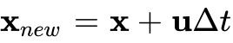) into a discrete transport problem closer to a permutation or a traffic flow model.
To respect the continuum physics calculated by the MPM grid while adhering to the discrete voxel constraint, we propose a Likelihood-Based Cellular Automata (CA) Transport.

4.1 Velocity-Guided Stochastic Transport
Instead of moving particles directly, the MPM velocity field  (which is now divergence-free) serves as a "guidance field" for the discrete movement of voxels. The advection step iterates through each active fluid voxel and examines its 14 BCC neighbors.
For a particle at location , we calculate a "flux probability" to each empty neighbor based on the projection of the velocity vector onto the direction vector 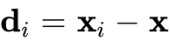:
The particle attempts to move to the neighbor with the highest probability. If the target cell is empty, the move is accepted. If the target cell is occupied, we handle the collision based on the phase of the occupier.
This "Move-to-Empty" logic, when driven by the pressure-corrected velocity field, solves the stacking problem. If a particle is at the bottom of a stack, the pressure solver will have generated a lateral velocity component. The "down" neighbor is occupied, but the "diagonal-side" neighbor might be empty. The velocity vector points diagonally, guiding the discrete transport to slide the particle into the empty slot. This allows the pile to relax into a level surface, mimicking the behavior of a hydrostatic fluid without requiring multi-particle compression.

4.2 Handling Collisions and Swaps
If the target cell is occupied by another fluid particle, a swap can be attempted to simulate turbulence or diffusion, though strictly preventing overlap is usually preferred for stability. If the target is occupied by a solid (terrain), the particle simply reflects or stays put. The decoupling of the physics calculation (on the grid) from the position update (on the voxels) is the key. The grid captures the global continuum behavior (pressure, gravity, momentum), while the discrete transport step ensures the validity of the voxel state (single occupancy).

5. Phase Interaction: Sand-Water Coupling
Simulating the interaction between sand and water voxels requires modeling them as a two-phase mixture. The artifacts typically observed—sand dissolving instantly, water ghosting through sand, or sand refusing to settle—stem from a lack of proper momentum exchange and constitutive coupling.

5.1 Continuum Mixture Theory on Sparse Grids
We adopt a multi-species MPM approach where sand and water are treated as separate phases that can conceptually coexist at the grid nodes, even if they are separated in the voxel cells.¹⁰ The total mixture density 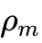 and velocity 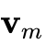 at a grid node are weighted averages of the sand and water contributions.
The interaction is mediated by a Momentum Exchange (Drag) Force. At each grid node, we calculate the relative velocity between the sand phase 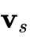 and the water phase 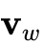. A drag force density 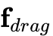 is applied to oppose this relative motion:
The drag coefficient depends on the permeability of the sand and the local volume fractions. In a voxel context, if a grid node gathers influence from 3 Sand voxels and 1 Water voxel, the "volume fraction" is effectively handled by the mass accumulation. This drag force is crucial: it causes moving water to "pull" adjacent sand voxels (erosion) and stationary sand to "slow down" water (porous flow), preventing the phases from passing through each other as ghosts.

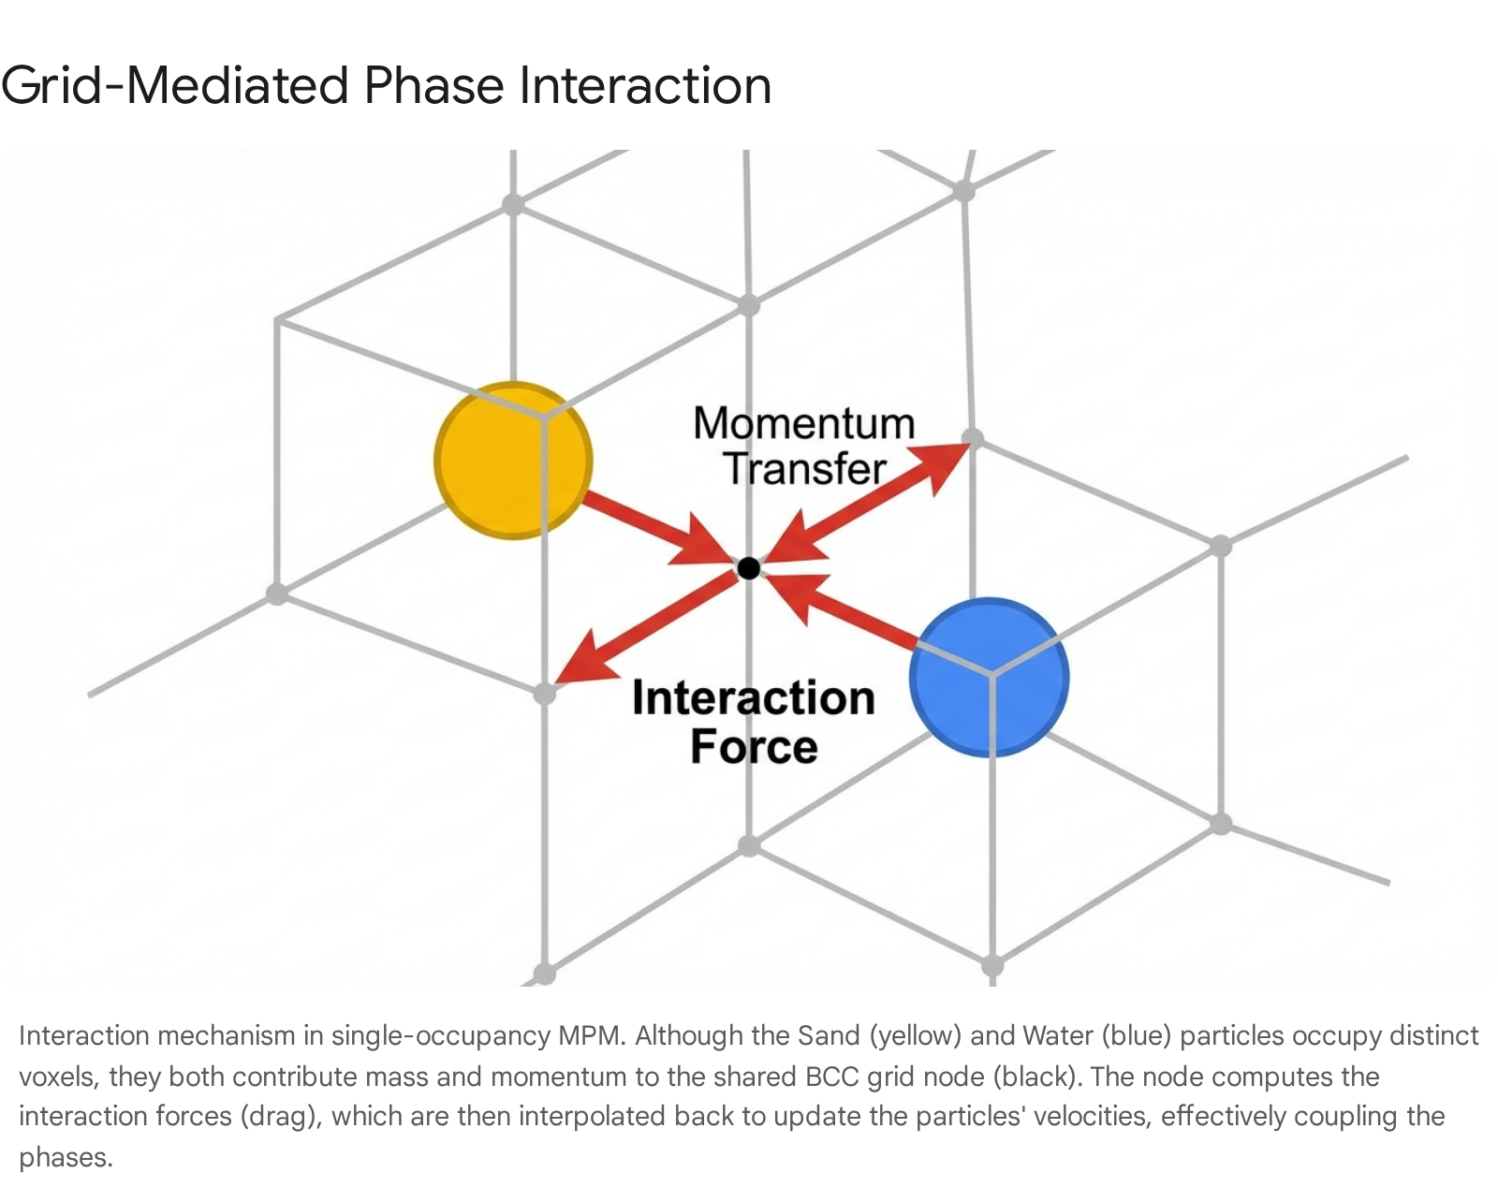

5.2 Saturation-Dependent Constitutive Model
To capture the transition from rigid sand blocks to flowing slurry, we must modify the sand's constitutive model based on water saturation. We employ the Drucker-Prager yield criterion for the sand, which defines a yield stress based on pressure and friction.
In a dry state, sand has high cohesion or friction, allowing it to support shear stress (form piles). As water interacts with sand, we track a "saturation" variable on the sand particles. This saturation can be approximated by the presence of water voxels in the immediate BCC neighborhood. We then modulate the yield surface parameters of the Drucker-Prager model ¹⁰:
As saturation approaches 1 (fully wet), the cohesion drops, and the yield stress decreases. This allows the MPM solver to treat wet sand voxels as a liquid-like material, enabling them to flow and slump under gravity (liquefaction), effectively solving the "rigid block" artifact.

6. Implementation Strategy: GPU and Compute Shaders
Implementing this hybrid BCC MPM solver requires a parallel architecture to maintain real-time performance. Compute shaders (e.g., GLSL in Godot or HLSL in Unity) are ideal for this workload.

6.1 Data Structures and Memory Layout
The BCC grid poses a challenge for memory indexing. A practical approach is to map the BCC lattice to a standard 3D texture using a "checkerboard" or "interleaved" mapping. A BCC grid of dimensions 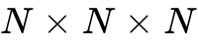 can be stored in a Cartesian texture of size 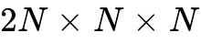 (or similar effective volume), where even and odd indices correspond to the two interleaved sub-grids. Alternatively, a linearized buffer with a spatial hash map is preferred for sparse domains to avoid allocating memory for empty air.
For the single-occupancy voxels, a R32Uint texture can store the particle ID for each voxel. This allows for 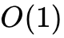 collision checks during the transport step. Particle data (velocity, mass, type, deformation gradient) should be stored in Structure of Arrays (SoA) buffers for coalesced memory access.

6.2 Comparison: LBM vs. Hybrid MPM
It is worth noting that the Lattice Boltzmann Method (LBM), specifically the D3Q15 model, naturally operates on a lattice very similar to BCC and handles pressure via streaming rather than a global Poisson solve.⁴ However, LBM struggles with the explicit "single occupancy" constraint for solids; it typically models density as a distribution function rather than discrete particles. The Hybrid MPM approach proposed here is superior for the user's specific constraints because it separates the physics (handled by MPM on the grid) from the occupancy (handled by the discrete transport), allowing for the rigid enforcement of "one particle per cell" that voxel engines require, while LBM would require complex re-normalization to prevent mass from "smearing" across cells.

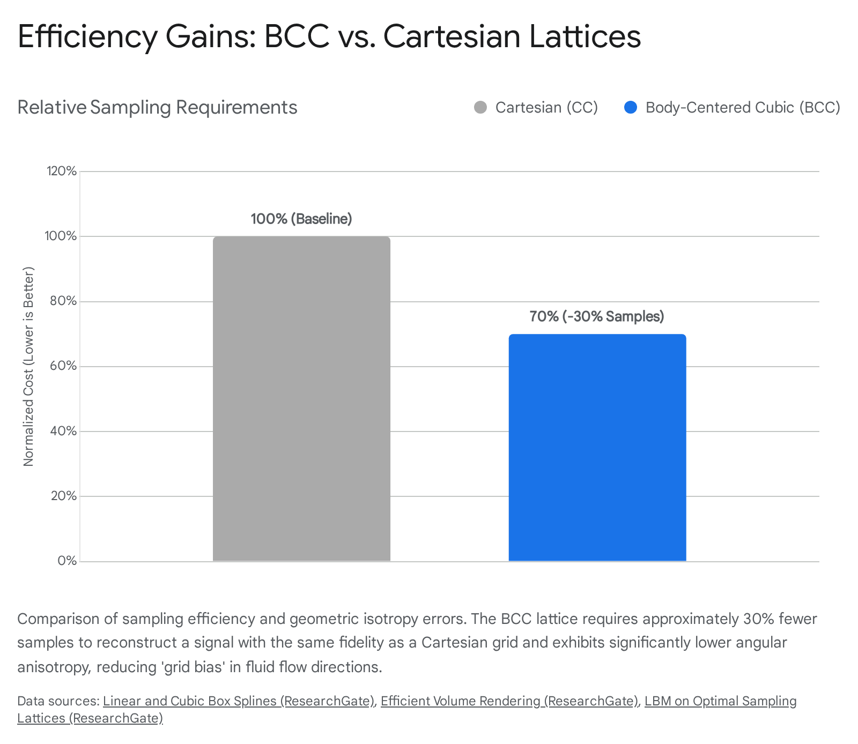

7. Conclusion
The successful implementation of a discrete voxel fluid simulation on a BCC lattice requires a departure from standard "game physics" cellular automata and a move towards a hybrid continuum-discrete model. The "water stacking" artifact is effectively eliminated by introducing an Eulerian Pressure Projection step that solves the Poisson equation on the 14-neighbor BCC stencil, generating the necessary lateral divergence-free velocities. The single-occupancy constraint is respected through a Likelihood-Based Transport scheme that uses this velocity field to guide discrete particle swaps without overlap. Finally, phase interactions are resolved by treating the grid as a mixing medium for momentum exchange and using saturation-dependent constitutive laws to model the liquefaction of sand. This architecture leverages the isotropic benefits of the BCC lattice while providing the robustness required for interactive voxel applications.

Works cited
- Linear and Cubic Box Splines for the Body Centered Cubic Lattice - EPrints, accessed February 10, 2026, https://eprints.cs.univie.ac.at/5018/1/2004_-_Linear_and_cubic_box_splines.pdf
- Linear and Cubic Box Splines for the Body Centered Cubic Lattice - ResearchGate, accessed February 10, 2026, https://www.researchgate.net/publication/220944201_Linear_and_Cubic_Box_Splines_for_the_Body_Centered_Cubic_Lattice
- Efficient Volume Rendering on the Body Centered Cubic Lattice Using Box Splines | Request PDF - ResearchGate, accessed February 10, 2026, https://www.researchgate.net/publication/222336072_Efficient_Volume_Rendering_on_the_Body_Centered_Cubic_Lattice_Using_Box_Splines
- The Lattice-Boltzmann Method on Optimal Sampling Lattices | Request PDF - ResearchGate, accessed February 10, 2026, https://www.researchgate.net/publication/24409875_The_Lattice-Boltzmann_Method_on_Optimal_Sampling_Lattices
- Efficient volume rendering on the body centered cubic lattice using box splines - MIP:Lab, accessed February 10, 2026, https://miplab.epfl.ch/pub/finkbeiner1001.pdf
- Enhanced Efficient 3D Poisson Solver Supporting Dirichlet, Neumann, and Periodic Boundary Conditions - MDPI, accessed February 10, 2026, https://www.mdpi.com/2079-3197/13/4/99
- Fluid Solver for Incompressible Flow in a Rectangular Domain with Arbitrarily-placed Inclusions A Senior Honors Thesis Presented - Brandeis University, accessed February 10, 2026, https://www.brandeis.edu/mathematics/docs/thesis-lamelas.pdf
- Chapter 30. Real-Time Simulation and Rendering of 3D Fluids ..., accessed February 10, 2026, https://developer.nvidia.com/gpugems/gpugems3/part-v-physics-simulation/chapter-30-real-time-simulation-and-rendering-3d-fluids
- Fast Fluid Simulations with Sparse Volumes on the GPU - ResearchGate, accessed February 10, 2026, https://www.researchgate.net/publication/325488464_Fast_Fluid_Simulations_with_Sparse_Volumes_on_the_GPU
- Multi-species simulation of porous sand and water mixtures - UC Davis Mathematics, accessed February 10, 2026, https://math.ucdavis.edu/~jteran/papers/PGKFTJM17.pdf
- Multi-species simulation of porous sand and water mixtures - ResearchGate, accessed February 10, 2026, https://www.researchgate.net/publication/318612741_Multi-species_simulation_of_porous_sand_and_water_mixtures
- Comparative study of the lattice Boltzmann collision models for simulation of incompressible fluid flows | Request PDF - ResearchGate, accessed February 10, 2026, https://www.researchgate.net/publication/327002017_Comparative_study_of_the_lattice_Boltzmann_collision_models_for_simulation_of_incompressible_fluid_flows

